December 5, 2017  11 am to 12 pm  OR  2 pm to 3 Pm  SW 214 Rockville Campus  In this one-hour presentation, participants will experience life as a MC Nursing student through a variety of activities while interacting with Nursing faculty and staff.  This program is open to Montgomery College students who have not been accepted or are not currently enrolled in the Nursing program.  Disability Accommodations and Services:  If you need a disability-related accommodation, please contact Laurie Williams, by phone: 240-567-5514, or email laurie.williams@montgomerycollege.edu .  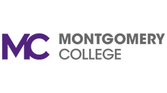 | Registration  Interactive session:  Skills Laboratory  ────  Simulation  ────  Q &A  Nursing Profession and Career Opportunities  Academic Progression  Contact Us:  ADN to BSN Pathway: adntobsn@montgomerycollege.edu  Mikka Newsome, Administrative Aide: 240-567-5623

