**Courage, Honesty, and Grace:**

An Evening of Poetry and Song with

Don Marbury

**Tuesday, April 9,**

**7:00 p.m.**

**Globe Hall**

**Book Signing and Reception**

**6:00 p.m. in the**

**Globe Hall Atrium**

Daytime event: Poetry Reading and Workshop

11:00 a.m. -12:30 p.m. April 9, 2019 HT216

**High Tech Building**

**Germantown Campus**

**20200 Observation Drive**

**Germantown, MD 20876**

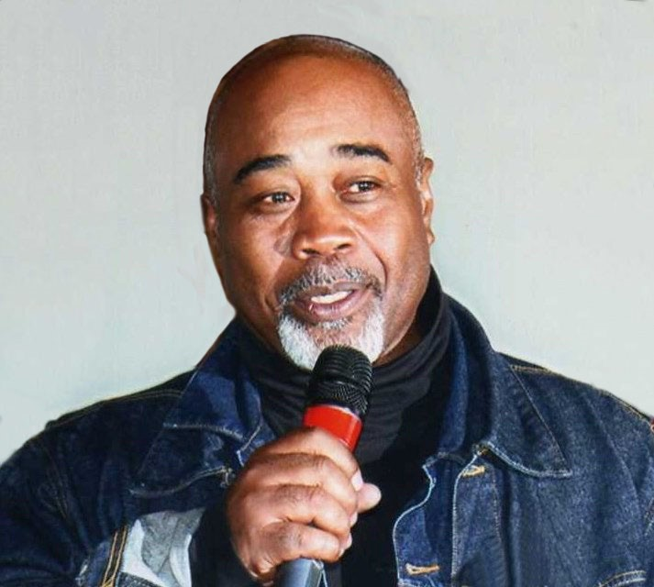

Donald L. Marbury, Senior Pastor of Ebenezer AME Church in Hagerstown, Maryland, recently published *My People, My People, My God*, a book of poetry, short stories and essays. Mr. Marbury taught Reading, Writing, and English at Montgomery College, Germantown for 18 years.

"Savor these poems, one or two at a time, like you would slice from a round of aged cheddar. If you have not heard Don Marbury's deep and resonate voice from his diaphragm, you will hear it in written words. From the Black experience? Certainly. But also American, like jazz."

**The Reverend Dr. David McAllister-Wilson, President, Wesley Theological Seminary**



***These events are free and open to the public. For questions or to request accommodations, please call the Humanities Department at 240.567.7766***

