 |  | 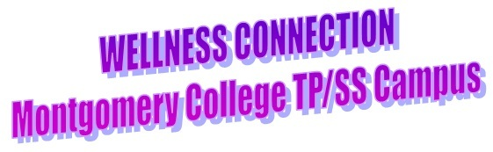
November 23, 2026 | Volume 3
     |  | Montgomery College Fitness News:  Our First “Fitness Happy Hour” event was a lot of fun. Thank you for joining us and we hope to have more fun events like this throughout the year.  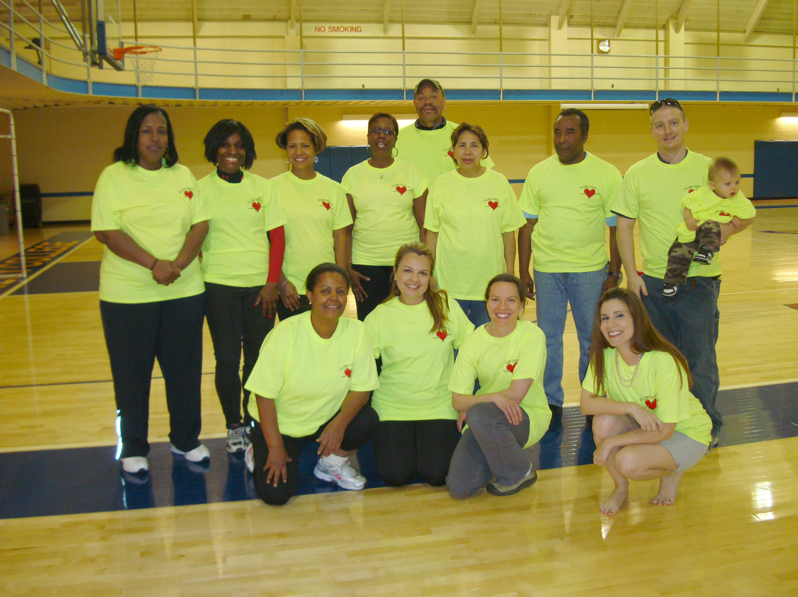  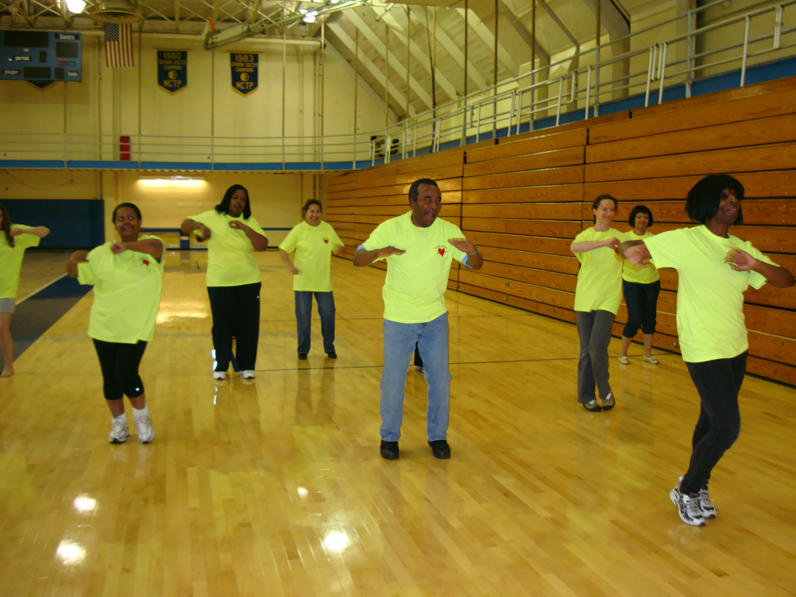  .  Zumba, bootcamp and Yoga all in one class!  Healthy Eating: Easy, Breakfast on the Go Ideas:  Pomegranate and Blueberry Cream Smoothie  400 calories  The powerful dose of antioxidants in pure pomegranate juice makes it taste too bitter for some, but creamy cottage cheese and coconut milk mellow out the intense flavor in this smoothie recipe.  Ingredients:  1 scoop vanilla protein powder  1 cup low-fat cottage cheese  2 Tbsp coconut milk  1 cup blueberries  2 Tbsp flaxseed meal  4 oz Pure Pomegranate juice  Directions: Combine all ingredients in a blender and blend until smooth. For a thicker shake add less water or more ice cubes.  Our Wellness Summer Schedule is on its way, please make sure your registrations are sent to Human Resources and that you sign in for every class you participate in. These documents are very important in order to keep our program running successfully.  Our featured class this month is Yoga for Desk Jockeys taught by Mercedes Santos who wrote this brief overview of the program.  According to several studies, most professionals sit an average of nine and a half hours a day. It almost sounds like a low figure, right? But start with eight hours at work, then add the commute, the restaurant, the bar, the couch . . . how many is that? Point is, we sit a lot and our body isn't really designed for it. Parking our rear for that long can create sore backs, shoulders and necks.  Participating in a Wellness activity as a part of your workday is a great way to get up out of that chair, and Yoga for Desk Jockeys is the perfect antidote to all that sitting.  In each 45-minute class you’ll stretch and strengthen the muscles of the shoulders, neck and lower back that are most affected by sitting at a desk and working on a keyboard. The class will also include standing poses, the perfect compliment to a desk job. Class ends with some time for relaxation; and because it’s yoga, it’s all done in concert with the breath, which in itself can reduce stress and help to create a greater sense of overall ease. You’ll also be provided with some yoga practices that you can do at your desk!  Join Mercedes Santos on Wednesdays from 11:30-12:45 in Falcon Hall 111 for Yoga for Desk Jockeys.  Special Events:  Bike to Work Day, May 18th, 2012.  'Ride in Good Company' on Bike To Work Day - May 18  Register for Bike To Work Day and join over 10,000 bicycle commuters in the Washington area for this free regional event that celebrates cycling. To participate, register at a designated 'pit stop' along your commuting route, where you get a free t-shirt, are treated to light refreshments, and entered to win prizes like bikes and messenger bags.  Takoma Park is joining the network this year with three pit stops in the City: at the Old Town Gazebo, on Sligo Creek Trail, and at the Takoma/Langley Crossroads. Whether traveling to work, school, or Metro, anyone commuting by bike the morning of May 18 can participate in this free event.  To register and learn more about the event, visit www.biketoworkmetrodc.org  In the Spotlight:  Staff Name: Mercedes Santos, Yoga instructor  When did you decide you wanted a career in fitness and why?  After retiring from the university of California as an equal opportunity analyst, mediator and investigator, I decided to become a yoga teacher. I had spent years helping to resolve workplace conflicts and was ready to work with people in a "feel good" kind of way.  What is the most frequent question you get as a Fitness professional?  How can I get myself to exercise on a regular basis?  Developing a regular exercise routine is like establishing any other habit, and what is helpful to each person varies. Set up a schedule, if possible chose something to do that you enjoy, and then just do it! This last point is key: don't allow yourself to get caught up in all the narratives about why you can't. Think of it like brushing your teeth - something that is a non-negotiable a part of your daily routine. Also, get a workout buddy; it really helps.  What is the funniest story/experience you can share while working in the fitness industry?  I can't think of anything that I can share . . . :-)  What is the most rewarding thing about your job?  At the end of the yoga class, everyone is happy, they're smiling; they feel more peaceful and better in their body and mind than when they started. Mediating conflicts was rarely like that!  Why do you enjoy working at Montgomery College and how does it differ from other places you teach fitness at?  Having worked in an educational environment I understand how important and also how challenging it can be to step away from the job during the day to adjust your perspective and to do something of benefit to yourself. I enjoy supporting MC employees in their efforts to do this.  I wish you all a wonderful month, stay active and healthy!  Lili Rojas  Wellness Coordinator, Takoma Park Campus.  Liliana.rojas@montgomerycollege.edu, 240-567-3967
  
  

