THE DIVISION OF HUMANITIES AND THE DEPARTMENT OF HISTORY
AND POLITICAL SCIENCE PRESENT:

U.S. POLITICS AND GOVERNMENT:
THE VIEW FROM ASIA

A PANEL DISCUSSION FEATURING

TAKESHI KURIHARA, CORRESPONDENT, NHK (JAPAN PUBLIC TELEVISION)

PRASHANTH PARAMESWARAN, SENIOR EDITOR, THE DIPLOMAT MAGAZINE

CHIDANAND RAJGHATTA, CORRESPONDENT, THE TIMES OF INDIA

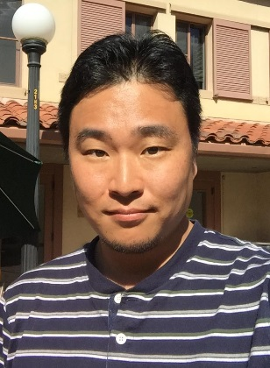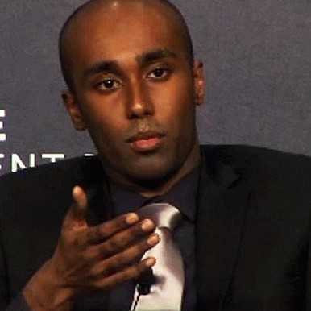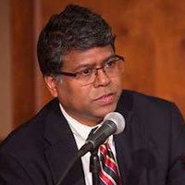

MODERATED BY PROFESSOR ANDREW KRIEGER, PH.D

THURSDAY, APRIL 11, 2019, 3:00 – 5:30 PM
THEATRE ARTS BUILDING
ROCKVILLE CAMPUS
This event is free and open to the public

