H1N1 Update
November 5, 2009

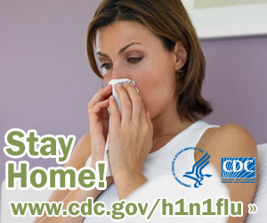

Availability of H1N1 Vaccine in Montgomery County (montgomerycountymd.gov)

Health officials recommend that everyone consider receiving an H1N1 vaccination when supplies are available. Dates and locations for clinics will be posted at www.montgomerycountymd.gov/h1n1flu as soon as information is available. In addition to local health departments, retail locations and some private physicians will be receiving the H1N1 vaccine, as well. Montgomery County’s flu hotline -- 240-777-4200 -- is available Monday through Friday from 9 a.m. to 5.

Status of the Montgomery College H1N1 Education and Prevention Program

Track Collegewide use of sick leave – The Office of Human Resources has created a program to track total sick leave taken each pay period for all non-faculty employees. Although the data indicates an upward trend in the use of sick leave, it is difficult to make any conclusions without data from prior years. We will continue to monitor the sick leave data for any trends.

Provide students and employees with notices/flyers – A large number of the CDC flyer “Take 3” Steps To Fight The Flu are available for distribution in classes, departments, and meetings. Please send any requests for flyers to robert.wirth@montgomerycollege.edu.

Distribute hand wipes – Our order for 200,000 hand wipes continues to be delayed by significant manufacturer backlogs due to a nationwide demand for the product. The current projected delivery date is 30 – 45 days.

Install touch free hand sanitizers – Nine additional dispensers for use at the Rockville and Takoma Park/Silver Spring campuses are part of a 1900 unit backorder at our supplier.

CDC Weekly 2009 H1N1 Flu Media Briefing, November 3, 2009 (cdc.gov)

Selected remarks by Thomas R. Frieden, M.D., M.P.H., Director, Centers for Disease Control and Prevention

For people with asthma and other underlying conditions it's particularly important to get vaccinated when vaccine becomes available and also if you have fever and cough to get treated promptly. People with asthma account for about 1/3 of all of the people hospitalized with H1N1 influenza.

There is almost no seasonal flu so far. A few strands here and there. Overwhelmingly, it's still H1N1 and it remains very tightly matched to the vaccine.

Vaccine Allocation and Distribution (cdc.gov)

1. How do project areas know how much vaccine is available for them to order?
CDC sends project areas a weekly 2009 H1N1 allocation report each morning as it does for seasonal influenza vaccine. The report indicates how much of each formulation of 2009 H1N1 vaccine is available for them to order.

2. What is the number of doses "allocated" for ordering?
The number of doses "allocated" for ordering is the amount that is at the distribution depots and ready for states to order. The quantity of vaccine allocated is based on the project area's population size. As an example, if 6 million doses total (3 million doses of nasal spray vaccine AND 3 million doses of injectable vaccine) are ready for ordering nationally (as of today) and a state has 10% of the US population, then their allocation for today is 600,000 doses total (300,000 doses of the nasal spray vaccine and 300,000 doses of injectable vaccine).

3. How is vaccine shipped to project areas?
CDC’s contractor for centralized distribution ships vaccine to hospitals, clinics, doctor’s offices, health departments, and other providers of vaccines that have been designated as vaccine-receiving sites by the Project Area (the project areas include all 50 states, the District of Columbia, 8 US Territories and freely associated states, and 3 large metropolitan health departments).

4. What kind of providers can be designated as vaccine recipients?
Providers that have the capability to receive, store and administer vaccine, including but not limited to provider offices, occupational health clinics, hospitals, local health departments, community vaccinators and pharmacies.
5. How many sites can a jurisdiction designate to receive vaccine?
There is a maximum of 150,000 sites to which vaccine can be shipped via centralized distribution. Project areas have received information about their allocation of sites.

6. How do project areas know how much vaccine is available for them to order?
CDC sends project areas a daily 2009 H1N1 allocation report each morning as it does for seasonal influenza vaccine. The report indicates how much of each formulation of 2009 H1N1 vaccine is available for them to order.

Frequently Asked Questions (flu.gov)

1. How long can a virus like novel H1N1 live on a surface outside its host?

The H1N1 virus is new. Research is being conducted to better understand its characteristics. Studies have shown that flu viruses can survive on hard surfaces and can infect a person for up to 2 to 8 hours after being left on items like cafeteria tables, doorknobs, and desks. Frequent hand washing will help you reduce the chance of getting contamination from these common surfaces.

Flu viruses may be spread when a person touches droplets left by coughs and sneezes on hard surfaces (such as desks or door knobs) or objects (such as keyboards or pens) and then touches his or her mouth or nose. But, routine cleaning will kill these germs.

2. What household cleaning should be done to prevent the spread of influenza virus?

To prevent the spread of influenza virus it is important to keep surfaces (especially bedside tables, surfaces in the bathroom, kitchen counters and toys for children) clean by wiping them down with a household disinfectant according to directions on the product label.

3. Does hand washing work if there is no hot running water?

The CDC recommends that you wash your hands thoroughly with clean, running water and soap. Use warm water if it is available.

If clean, running water is not available use an alcohol-based hand sanitizer.

4. Can people get 2009 H1N1 flu virus by eating food products?

Influenza viruses are not known to be spread by eating food items. Influenza viruses are spread through inhalation or through touching contaminated surfaces and then touching the mouth, nose, or eyes.

5. How should linens, eating utensils and dishes of persons infected with influenza virus be handled?

Linens, eating utensils, and dishes belonging to those who are sick do not need to be cleaned separately, but importantly these items should not be shared without washing thoroughly first.

Linens (such as bed sheets and towels) should be washed by using household laundry soap and tumbled dry on a hot setting. Individuals should avoid “hugging” laundry prior to washing it to prevent contaminating themselves. Individuals should wash their hands with soap and water or alcohol-based hand rub immediately after handling dirty laundry. Eating utensils should be washed either in a dishwasher or by hand with water and soap.

Maryland Influenza Surveillance Report - Week Ending Oct. 17, 2009**
** Data for week ending October 24 is not available as of November 4, 2009.

Emergency Department ILI Reports (ESSENCE)

Last week, a total of 36,350 people visited Maryland emergency departments that participate in ESSENCE. Of those, 3,196 (9%) visits were for flu-like illness. This proportion is an increase over the previous weeks. ESSENCE is a system monitored by the Office of Preparedness and Response. For more information, visit: http://bioterrorism.dhmh.state.md.us

Emerging Infections Program Flu Hospitalization Surveillance

Last week, a total of 74 people were reported hospitalized due to influenza. Those in the 25 to 49 age group constituted the largest section of those hospitalized with 23 reported hospitalizations in that group.

Predominant Influenza Strain Information (marylandfluwatch.org)

This graph shows that type A (H1N1) 2009 (formerly known as the "swine flu") continues to be the predominant strain of influenza in Maryland.

Outpatient Illness Surveillance (cdc.gov)
Nationwide during week 42, 8.0% of patient visits reported through the U.S. Outpatient Influenza-like Illness Surveillance Network (ILINet) were due to influenza-like illness (ILI). This percentage is above the national baseline of 2.3%.
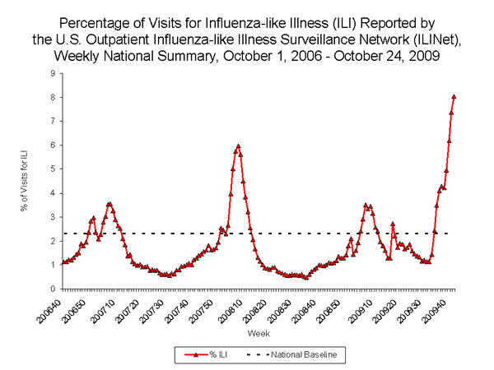

American College Health Association Pandemic Influenza Surveillance
Influenza-Like Illness (ILI) in Colleges and Universities

Limitations: state case counts and rates do not represent the state’s entire population, or the rate of ILI among all institutions of higher education in the state. The case counts and rates only represent those institutions of higher education that participate in the surveillance program.

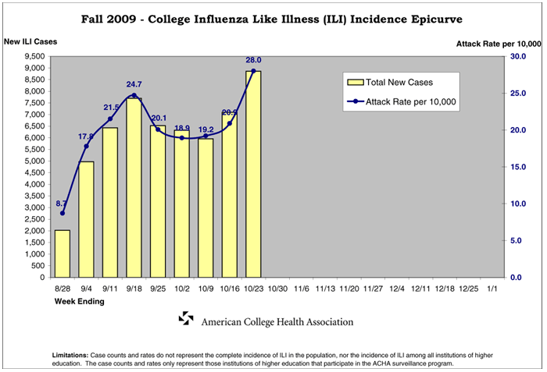

Links to Additional Information
U.S. Government flu information http://www.flu.gov

Centers for Disease Control and Prevention http://www.cdc.gov/swineflu/

Montgomery County http://www.montgomerycountymd.gov/h1n1flu

Maryland Department of Health & Mental Hygiene http://www.dhmh.maryland.gov/swineflu/
Montgomery College Contact Information
For more information about Montgomery College’s H1N1 Education and Prevention Program, please contact Bob Wirth by e-mail at robert.wirth@montgomerycollege.edu or 240-567-4308, or Steve Maloney by e-mail at stephen.maloney@montgomerycollege.edu or 240-567-4292.

