THE DIVISION OF HUMANITIES AND THE DEPARTMENT OF HISTORY
AND POLITICAL SCIENCE PRESENT:

U.S. POLITICS AND GOVERNMENT
THROUGH EUROPEAN EYES

A PANEL DISCUSSION FEATURING

GUNNAR SCHULTZ-BURKEL, FORMER SENIOR CORRESPONDENT, ARD (GERMAN PUBLIC TELEVISION)

DAVID SMITH, WASHINGTON BUREAU CHIEF, THE GUARDIAN

MARCIN WRONA, WASHINGTON BUREAU CHIEF, TVN (POLAND)

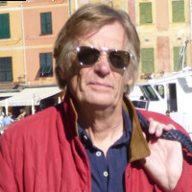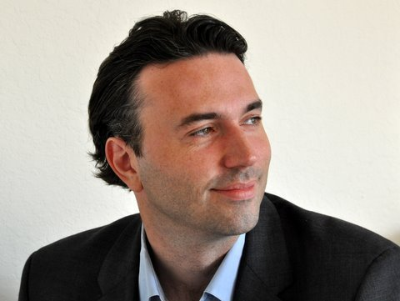

MODERATED BY PROFESSOR ANDREW KRIEGER, PH.D

TUESDAY, OCTOBER 8, 2019, 12:45 – 2:30 PM
SCIENCE WEST ROOM 301
ROCKVILLE CAMPUS
This event is free and open to the public

