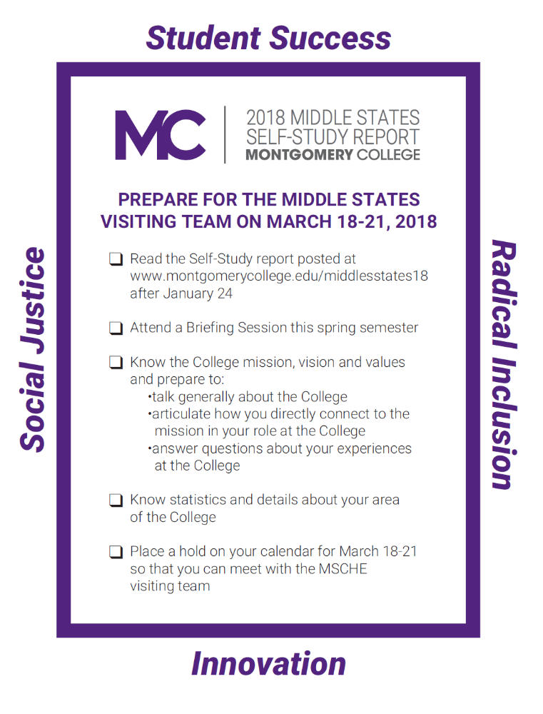



SPRING 2018
LISTENING TOUR SCHEDULE

DATE | TIME | LOCATION | CAMPUS
Feb 12 | 12:30-1:30 pm | SC 151 | Rockville
Feb 20 | 3:30-4:30 pm | PK 178 | Germantown
Feb 22 | 10:00-11:00 am | MK 300 | Mannakee
Feb 27 | 10:30-11:30 am | CT S108 | Central Services
Mar 1 | 3:30-4:30 pm | HC 222 | TP/SS
Mar 6 | 3:30-4:30 pm | SW 301 | Rockville

