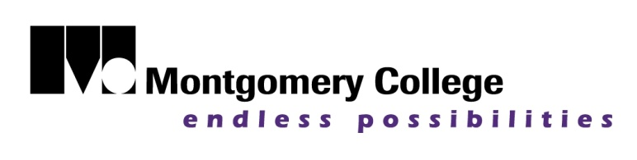  

**Montgomery College Citizenship Program,**

**through Catholic Charities Immigration Legal Services,**

**will be offering a:**

**FREE CITIZENSHIP WORKSHOP**

**DATE: Saturday, January 24, 2015**

**TIME: 9am-1pm**

**WHERE:** East County Regional Center

3300 Briggs Chaney Road, Silver Spring, Maryland 20904

**PURPOSE:** Staff attorneys and trained volunteers will assist eligible applicants

in completing citizenship applications.

**Pre-Registration Required. To pre-register, please call :**

**Anita Mwalui at 240-777-8406 or** **301-890-1983**

**WHAT TO BRING TO WORKSHOP:**

* **“Green Card” (Lawful Permanent Resident Card)**
* **Two Passport Photos**
* **A personal check or money order payable to “U.S. Department of Homeland Security” for $680**
* **All Passports used to travel out of the U.S. since obtaining Lawful Permanent Residence.**
* **List of trips made outside of the U.S. in the last 5 years.**
* **Dates and addresses for the last 5 years for all places where you have lived and worked.**
* **Biographical Information for current spouse: Birth & marriage date, A#, and current address.**
* **Information for former spouses such as full legal name, immigration status at the end of marriage, place & date of birth, marriage & divorce date.**
* **Biographical information for all children (including adult, adopted or deceased): Place & date of birth, A#, and current address.**
* **All records from Department of Motor Vehicles (DMV) for any tickets, DUI, license suspension, etc.**
* **Court Dispositions for any arrests or charges.**

**Please note : If you have a criminal conviction, you are NOT eligible for this workshop. Feel free to contact Catholic Charities or a reputable attorney for a legal consultation.**